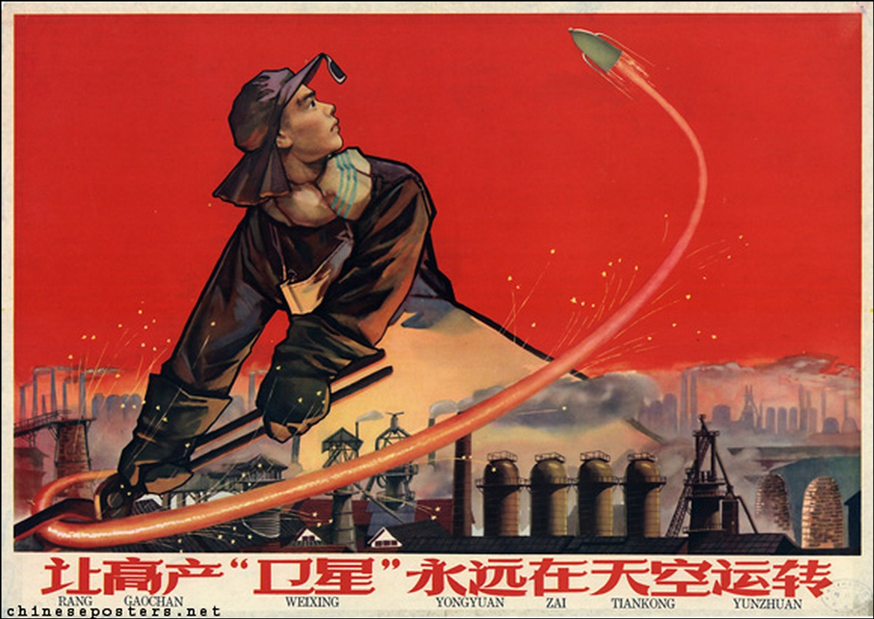

Great Leap Clicker

Can You Save Your Village?

Version 1.0

Eddie Song

Somber Lane Studios

2017 May 16

All rights reserved.

# Game Overview

## Game Concept

Great Leap Clicker is a clicker/idle game set during the Great Leap Forward, an economic and social campaign by the Communist Party of China from 1958 to 1962. The campaign aimed to transform the country into a socialist society through rapid industrialization and collectivization.

The game is designed to express the fear, anxiety and madness that overwhelmed the lives of peasants in some rural areas during the Great Leap Forward. It is meant to serve as a reminder of the excruciating lesson we learned through history.

## Feature Set

[Placeholder]

## Genre

Clicker/Idle, Resource Management, Simulation

## Target Audience

Everyone. Knowledge of the Communist China’s history, and the Great Leap Forward in particular, may enhance the gameplay for some.

## Game Flow Summary

The game will have a simple interface that tracks resources, number of villagers, and upgrades. Players will have limited amounts of time to reach milestones in order to keep progressing through the game. In order to reach the milestones in time, players will need to manage their resources effectively to keep their resource production at an optimal level.

## Look and Feel

The game is design to match the art style of propaganda posters produced during the Great Leap, which is very distinct. Copious amounts of red will be used as the theme color, a reference to the historical era as well as the art style.

The game should feel happy and motivated in the early stages, and a bit hectic and anxious in the later stages. However, a feeling of dread and desperation should loom over the entire game, and make its presence known once in awhile.

## Project Scope

[Placeholder]

# Gameplay and Mechanics

## Gameplay

### Game Progression

[Placeholder]

### Mission/Challenge Structure

[Placeholder]

### Objectives

[Placeholder]

### Play Flow

[Placeholder]

## Mechanics

### Objects

### Actions

### Combat

### Economy

## Screen Flow

## Game Options

## Replaying and Saving

## Cheats and Easter Eggs

# Story, Setting and Character

## Story and Narrative

### Background

The Great Leap Forward is widely considered to be a disaster in all aspects. In particular, exaggerated levels of grain production were reported by middle-level government officials to win reputation and commendation, which led to an overwhelming amount of grain being taken by the state and very little left for the peasants, if any at all. In some areas, starvation set in, and the trend quickly evolved into the Great Chinese Famine during 1959 to 1961.

The number of deaths caused by the Great Leap Forward has been estimated to be 18 to 55 million, almost all of which are associated with the Great Chinese Famine.

### Plot Elements

[placeholder]

### Game Progression

[placeholder]

### Cut Scenes

[placeholder]

## Game World

### General Look and Feel of World

### Area #1

#### General Description

#### Physical Characteristics

#### Levels that use area

#### Connections to other areas

### Area #2

## Characters

### Character #1

#### Back Story

#### Personality

#### Appearance

#### Abilities

#### Relevance to Story

#### Relationship with other Characters

#### Statistics

# Levels

# Interface

# Artificial Intelligence

# Technical

# Game Art

# Secondary Software

# Management

# Appendices